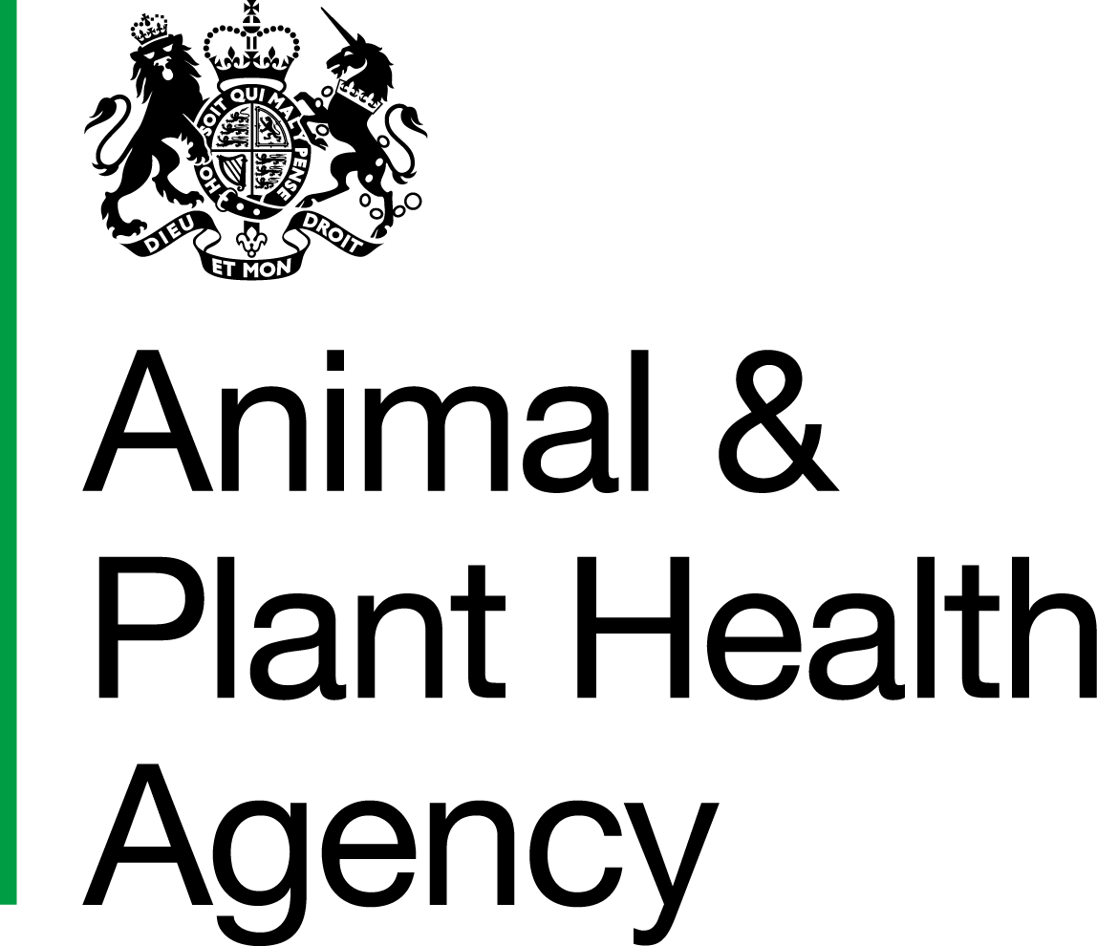Department for Environment, Food and Rural Affairs
Scottish Government
Welsh Government

Guidance for Supervising Veterinarians for Home Isolation of Pets Imported from Ukraine

As part of the Government’s response to the exceptional situation in Ukraine, we are allowing certain pets that meet strict criteria for a limited period of time to complete the rabies risk management process in officially authorised home isolation. The Animal and Plant Health Agency (APHA) are triaging pets against a strict set of risk criteria to determine whether isolation in a home setting would be suitable.
Following approval, supervising Veterinarians can expect to be contacted by APHA or one of APHA’s Veterinary Delivery Partners who will be coordinating this work on APHA’s behalf if a pet animal in your locality is suitable to be released into home isolation. If you agree to act as the veterinary supervisor for this pet animal, you will be sent a letter of appointment. You will need to visit the home isolation site as soon as possible, aiming to complete it within two working days of receipt of your letter. Factors outside of your control may increase this period, for example unavailability of the homeowner to accommodate a visit.
The site must be assessed against the standards (outlined below) and you will need to provide written confirmation to APHA (ukraine.homeisolationandbloodtests@apha.gov.uk) on whether the site meets those standards. A checklist will be provided which must be completed and returned. This will include information on any resident pets already in the house. Where the standards are met, APHA will then issue a licence for officially authorised home isolation. This would be for a set period of time, until the pet animal has completed the rabies risk management process. This licence will set out the conditions that must be met. This will be issued to the owner and a copy sent to you as the nominated approved veterinary supervisor.
Veterinary supervision will play an important role in the home isolation of these animals. The following will be the key requirements of you in your role as a supervisory veterinarian:
- Weekly telephone call to the pet owners (or authorised representative) to confirm that the conditions are being met and that animals remain healthy. You will need to agree at the initial visit who else, if anyone, is authorised to provide this information, in addition to the owner of the animal. It may be the homeowner for example
- A formal record must be kept of any calls and contact with the pet owner
- The pet owner will be required to take a daily written note of the health and wellbeing of the animal, this must include any changes in behaviour or appetite, even if only temporary. This should be discussed at the weekly calls
- The pet owner will be provided with your contact details and will contact you with any concerns about their pet. Written records must be kept of any concerns and any veterinary visits
- We will provide guidance to the owner on clinical signs to be aware of. They will report any of these to you as the supervising Veterinarian. You should immediately report any deaths to APHA
- You will also act as a key point of contact if the pet owner has any immediate concerns with the pet’s health and welfare
- Beyond providing advice and responding immediately to concerns in relation to any Rabies query, you will not be expected to administer or dispense treatment for the pet as part of your appointment as an authorised veterinary supervisor. You will need to liaise with the appropriate clinical Veterinary Surgeon (who may also be yourself but not in the approved supervisor role) to ensure that both of you are fully aware of the situation and implications where there is disease or injury to the animal
This does not include situations where Rabies or other notifiable disease is suspected. This must be reported immediately to APHA in the usual way.
We have produced a set of requirements and standards for pet home isolation that must be strictly adhered to in order to minimise the risk of disease transmission if identified. Adhering to these requirements is the responsibility of the host and pet owner. The pet owner will have also been given a set of these requirements when their animal left quarantine or port of entry, as well as some guidance on what to do if they are scratched or bitten. The home isolation requirements are as follows:
- The animal(s) must not leave the perimeter of the authorised premises.
- Cats and ferrets must be kept indoors at all times and care must be taken not to leave doors or windows open. Cat flaps should be locked at all times.
- There must be a private, secure, escape proof garden for dogs. Dogs can be allowed into the garden for toileting but must be kept on a lead at all times.
- Dogs cannot be exercised or walked outside this garden.
- Faeces must be quickly picked up, double bagged and disposed of carefully into a secure bin which cannot be accessed by other animals or wildlife.
- Contact between the animal(s) and children should be minimised and children must not feed or play with the animal(s).
- Numbers of visitors to the authorised premises should be minimised and any visitors must be prevented from coming into contact with the animal.
- No other animals may visit the authorised premises.
- You must cooperate with the authorised Veterinary Surgeon at all times when requested. You will receive a weekly telephone call and may receive visits from the authorised Veterinary Surgeon to confirm that these conditions are being met and animals remain healthy. If the authorised Veterinarian has any concerns about the health of any animal in the household, access to the premises will be required.
- The animal owner must take a daily note of the health and wellbeing of the animal and discuss this with the authorised veterinary surgeon at the weekly calls.
- The animal owner will be provided with contact details for the authorised veterinary surgeon and asked to contact them with any concerns about their animal, including biting or scratching incidents or changes in behaviour. Records must be kept of any concerns and any veterinary visits.
- The animal owner must follow the guidance provided on clinical signs to be aware of and report any clinical signs or the death of the animal to the authorised veterinary surgeon.
Additional conditions may be included where APHA permit animals to be housed with resident pets:
- Resident cats or ferrets that may come into contact with the animals subject to the licence must also be kept indoors at all times.
In addition to these requirements, we recommend that:
- Where other pets are resident in the authorised premises, it is strongly recommended that resident dogs, cats or ferrets are rabies vaccinated (if they have not been vaccinated before). Defra will cover the costs of these vaccinations.
- Resident dogs in contact with Ukrainian animals must be walked on a lead at all times and muzzled when outside the premises.
- People who are immunocompromised should not live with the animals during the isolation period.
- Where there is more than one animal from Ukraine being isolated at the same premises, all animals coming from Ukraine should arrive together.
Please note that the animal owner or anyone caring for it must fully meet the welfare needs of the animal, with regards to its needs for a suitable environment, suitable diet, the ability to exhibit normal behaviour patterns within the constraints of isolation, any need it has to be kept with, or apart from, other animals being isolated, and its need to be protected from pain, suffering, injury and disease. When the animal is being transported, it must be transported by an authorised carrying agent. This includes where the animal needs veterinary assistance in an emergency. The owner must inform the vet before the animal arrives at the practice of its status as an animal undertaking officially authorised home isolation.
Officially authorised isolation is aimed primarily at managing the risk of rabies and the tapeworm Echinococcus multilocularis, but there are a number of other endemic diseases in Ukraine including distemper, Brucella canis and certain tick-borne diseases that may need to be addressed while the animal is in official isolation. All animals will have been treated for ticks and fleas prior to entering home isolation. Owners should be advised of their responsibility and the need to arrange appropriate veterinary advice, investigation and care.
If you have suspicion of rabies at any time you must report it immediately by calling the Defra Rural Services Helpline on 03000 200 301.
It is important that the officially authorised home isolation guidance is closely followed by the pet owner. If you have any concerns about the suitability of the home for the number or type of pets being housed, or the pet owner not complying, please contact APHA via the Defra Rural Services Helpline on 03000 200 301 for further guidance.

APHA is an Executive Agency of the Department for Environment, Food and Rural Affairs and also works on behalf of the Scottish Government, Welsh Government and Food Standards Agency to safeguard animal and plant health for the benefit of people, the environment and the economy.

