Department for Environment, Food and Rural Affairs  Scottish Government  Welsh Government | 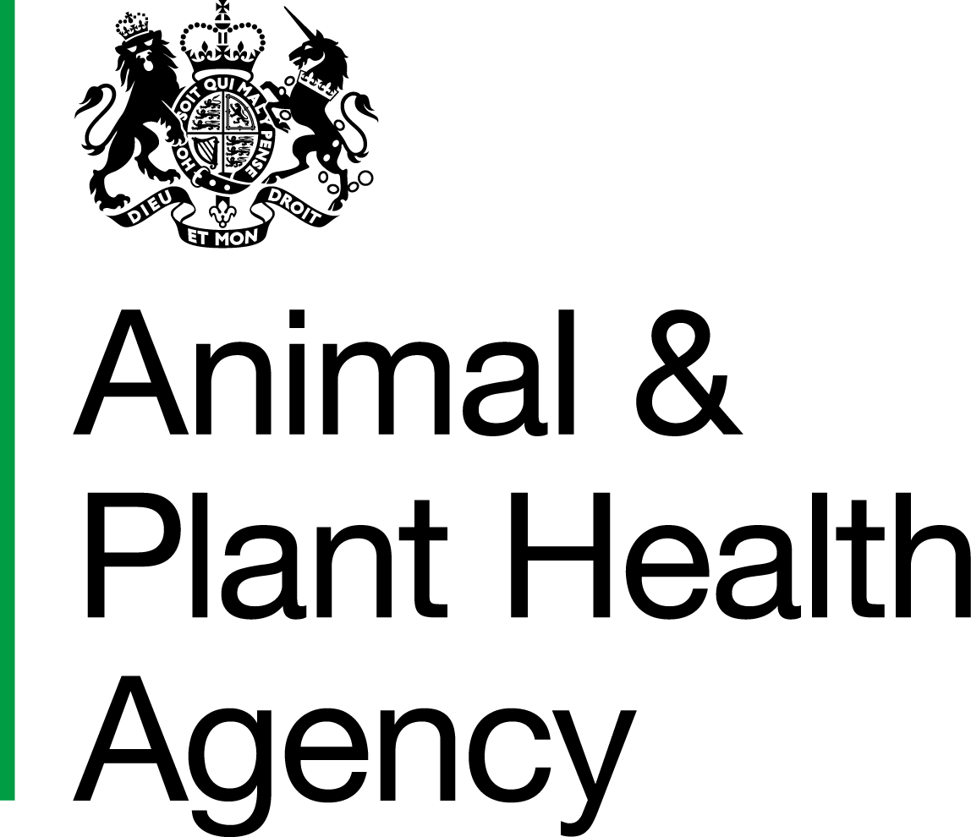
Request to Undertake Private TB Testing of Non-bovine Species

1. Application to Test Section (to be completed by the Private Veterinary Surgeon (PVS))

I am writing to seek the agreement of the Secretary of State/Scottish Ministers/Welsh Ministers* to carry out a TB test on the following non-bovine animals:
*delete as appropriate

(Insert Name and Address of the keeper where the test is to be undertaken) | Species:
 | No. of animals:
 | Date of test:
Postcode | CPH/Customer No.

Is this test for export purposes? |  |  |  |  | Yes |  | No
If no, what is the reason for the test? (i.e. pre or post-domestic movement testing, voluntary testing scheme, etc.
Do you have experience of skin testing the species to which this request applies? |  |  |  |  | Yes |  | No
If No, you must arrange for this test to be conducted under the supervision of a veterinary surgeon, who is experienced in testing the species to which this request applies and has the OCQ(V)-TT qualification.
If Yes, what experience do you have that demonstrates your competency to carry out the skin test, in addition to holding the OCQ(V)-TT qualification?
Is this test: | Skin Test |  | Blood Test

Signature Tel. no.
Official Veterinarian
Name in block letters Date
Email to:
Veterinary Practice Tel. No.
All completed forms should be emailed to:
- In England: CSC.TBOS@apha.gov.uk
- In Scotland: ScotlandEndemics@apha.gov.uk
- In Wales: APHAWalesTBCaseManagementTeam@apha.gov.uk

2. Consent Section (to be completed by Animal and Plant Health Agency (APHA) Veterinary staff)
Consent is given to you undertaking the tests set out above. All test results must be notified to your local APHA office within the target time.
Signature
APHA Veterinarian
Name in block letters Date
Note 1: For camelids include a copy of this declaration of consent along with the Camelid TB Serology Package - Private Sample Submission Form (TN186) with any clotted bloods submitted to Starcross Veterinary Investigation Centre (VIC) for TB serology tests.
Note 2: In Wales, it is not permissible to inject tuberculin only to boost the sensitivity of a subsequent antibody test for TB without reading the skin test response at 72 hours.

3. Submission of Results (to be completed by the Private Veterinary Surgeon (PVS))
Send this declaration (part 3 completed) with Tuberculin Test Chart for Non-Bovine Animals (TN52A)/Non-Bovine - Tuberculin Test Report and Certificate of Clinical Inspection (TN52B), and subsequently with blood test results in the case of animals having both test types applied, to APHA, using the email addresses shown in section 1.

Below are the results from the TB testing of this non-bovine herd/flock:
No. of Reactors:
No of Inconclusive Reactors:
Signature
Official Veterinarian
Name in block letters Date

Data Protection
For information on how we handle personal data please go to www.gov.uk and search Animal and Plant Health Agency Personal Information Charter.

APHA is an Executive Agency of the Department for Environment, Food and Rural Affairs and also works on behalf of the Scottish Government, Welsh Government and Food Standards Agency to safeguard animal and plant health for the benefit of people, the environment and the economy.
HM3 Stamp | Name: |  | Date Received: |  | WS ID:

